#### DRAFT – Work in Progress

#### Timeline of the COVID-19 Pandemic

1 December 2019 cases of pneumonia of an unknown cause surface in Wuhan City, in the central Chinese province of Hubei. It was reported to the World Health Organisation (WHO) on 31 December 2019. The virus was identified and isolated by early January, China shared the genetic sequence of the virus for countries to use in developing diagnostic kits.

24 January NZ MoH sets up a team to monitor the situation. By late January it had spread through China and into Thailand, Japan and South Korea. Three days later it had spread to Australia, Taiwan, Hong Kong, Macau and the United States. 30 January Kiwis evacuated from Wuhan.

3 February NZ Government placed entry restrictions on foreign nationals traveling to NZ from or through mainland China. Those entering the country had to self-isolate for 14 days. 6 February 193 evacuees from Wuhan arrive in Auckland and are quarantined in Whangaparaoa. 8 February Diamond Princess cruise ship harboured in Yokohama – 64 passengers including two Kiwis are infected and quarantined in their cabins. By 22 February 634 cases confirmed on the ship.

On 11 February 2020 the coronavirus disease was named COVID-19. At this time there were 43,103 confirmed cases and 1,018 people have died worldwide. (More than the total number of deaths during the SARS outbreak of 2002-04.) 19 February first case reported in Iran.

NZ reported its first case of COVID-19 on 28 February (from Iran). Its second case was reported on 4 March (from Italy). Health staff begin meeting direct flights from Hong Kong, Japan, South Korea, Singapore and Thailand on 29 February.

The week of 7-13 March Canterbury reported its first cases. By 8 March more than 100 countries reported cases of COVID-19 and the global number of reported cases exceeds 100,000. 10 March the population of Italy is put in lockdown.

**On 11 March 2020 the WHO declares an official pandemic.**

14 March the NZ government announced that anyone entering the country must self-isolate for 14 days (except those arriving from the Pacific). Cruise ships were banned. Travelers were requested to register with Healthline. Healthline monitored people in self-isolation.

By 19 March there were 28 cases in NZ, all linked with overseas travel. Indoor gatherings of more than 100 people were cancelled. For the first time in history, NZ borders are closed to all but NZ citizens and permanent residents.

21 March a four level alert system was announced by the NZ government.

By 23 March the number of cases in NZ exceeded 100. The country moved from **Alert Level 2** to **Level 3**. People were instructed to stay home, schools were closed from 24 March. All non-essential businesses closed. Travel was limited.

25 March a state of emergency was declared in NZ; the country went into **Alert Level 4** and into lockdown at midnight for at least the next four weeks.

On 29 March the first COVID-related death in NZ was announced. There were now 514 cases in NZ. On 5 April NZ had 1,039 cases and 12 clusters. About 2% of cases appeared to be the result of community transmission. 6 April UK Prime Minister Boris Johnson is hospitalised.

Health Minister David Clark demoted after admitting to having taken his family to the beach.

6 April Rosewood Rest Home announced as first Christchurch cluster. Residents transferred to Burwood Hospital.

In Canterbury over the coming days clusters were announced at Rosewood aged residential care facility (54 cases), George Manning House (20 cases), and a workplace (10 cases).

Globally the number of cases has surpassed 2 million; more than 30,000 people in the USA have died.

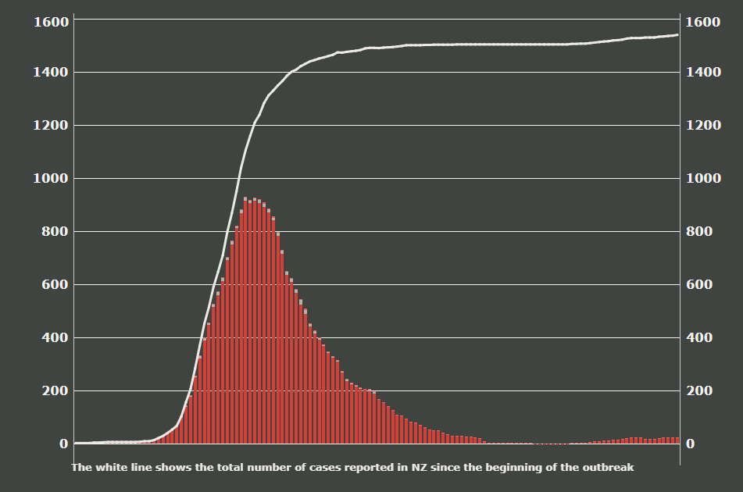

1: From 29 January to 9 July 2020

NZ returned to **Alert Level 3** on 29 April when the total number of confirmed and probable cases of the disease were 1,474. Fast food outlets could open with strict physical distancing practices. More people returning to work.

On 4 May no new cases are reported for the first time since 16 March. 8 May total number of cases in NZ is 1,490 with 90% of them recovered, 143 active cases.

7 June Brazil has surpassed Italy as the country with the third highest (35,930) COVID-19 related death toll after the US (110,110) and UK (40,625). 8 June MoH reports no more active cases in the country. At 11.59 NZ moves to **Alert Level 1**. Border controls continue – people entering the country will be tested and placed in mandatory 14-day managed quarantine or isolation facilities.

16 June two new cases announced related to travellers from the UK. By 29 June 2020 globally the number of cases has topped 10 million with more than 500,000 deaths. There are 22 active cases in NZ in quarantine facilities.

<https://shorthand.radionz.co.nz/coronavirus-timeline/>

# Timeline of COVID-19 Pandemic (with local actions)

1 December 2019 – Cases of pneumonia of unknown cause surface in Wuhan City.

31 December 2019 – Reported to WHO.

Early January – China shared genetic sequence of the virus.

*21 January – CPRG Comms and national updates sent out. 29 and 31 January CPRG updates distributed.*

24 January – MoH set up a team to monitor the situation.

30 January – NZ citizens evacuated from Wuhan.

3 February – NZ government placed entry restrictions on foreign nationals from or through mainland China.

11 February – Coronavirus disease named COVID-19.

*25 February – Akshay Shukla appointed as Response Manager. CPRG updates distributed 3, 20 and 28 February.*

28 February – First case reported in NZ.

*2 March – First approaches made to practices by CPRG re becoming designated practices.*

4 March – Health staff start meeting flights from certain countries.

7 March – First cases in Canterbury reported.

*10 March – PPE distribute to practices. Masks in short supply.*

11 March – WHO declares an official pandemic.

*17 March – MoH asked CDHB to set up CBAC ASAP. Primary EOC activated. CPH and Labs join the EOC. First funding for general practice assessment and testing agreed. PPE a priority. Location of urban CBAC agreed. Critical shortage of swabs. Discussions with Homecare Medical re triage. More PPE distributed to all practices. Low supply of hand sanitiser. HealthPathways on board.*

19 March – NZ borders closed to all but citizens and permanent residents.

22 March – RCGPNZ letter sent to all GPs directing reduction of in-person consultations by 70%.

*24 March – Nurse telephone triage team established to manage CBAC referrals. SITREPs to CDHB ECC start. Ashburton CBAC open. Primary EOC meeting daily. CPRG updates distributed 2, 6, 17, 18, 19, 23, 24, 25, 27, 30 and 31 March.*

25 March – State of emergency announced in NZ; Alert Level 4 put in place; country in lockdown.

29 March – First COVID-related death in NZ, a woman in Greymouth.

*5 April – 5 CBACs open.*

*6 April – Rosewood residents transferred to Burwood Hospital. ARC a focus of Primary and Secondary care. CDHB Staff being tested at own facility. ERMS facility for ePrescribing went live.*

9 April – The first Rosewood resident dies. A total of 12 people in Canterbury and 22 people in NZ would eventually die from COVID-related disease.

*April – CPRG updates distributed 2, 3, 6, 7, 8, 9, 14, 17, 20, 22, 24 and 28 April. New COVID page developed on CPRG website. Electronic order form for PPE on website.*

*May – CPRG updates distributed 4, 7, 8, 14, 19, and 22 May.*

*June – CPRG updates distributed 4, 10, 18, 25 June.*

16 June – Two new cases associated with UK travellers announced.

*Blue italic = CPRG activity*

Last worked on 9 July 2020 – Deborah C