Emergency Contact List
Sector Coordinator Role
Sector Coordinators in the Emergency Operations Centre (EOC) are responsible for being the main contact to and for general practices and community pharmacies in Canterbury.
Every practice and pharmacy has been organised into a ‘LEG’ (local emergency group) and been given instruction how to support each other, especially in the first hours after an emergency.
Once an EOC is activated (on the call of the Primary Care Coordinator), and depending on the nature and location of the emergency event, Sector Coordinators will be asked to liaise with their sector practices and pharmacies to determine the scale of the emergency in their area, and their specific need for support, if any.
This information will be documented by the sector coordinator, then collected and collated by the EOC Intel function in order to give a perspective on the status of primary care and delivery of health services to patients in each area to the DHB, Civil Defence or Ministry of Health.
It is recommended that every Sector Coordinator maintain a list of their practices and pharmacies, both in electronic and print form.
To view/print a list of general practices and pharmacies in sectors
- Go to ResOURce, go to Hub / Contacts.
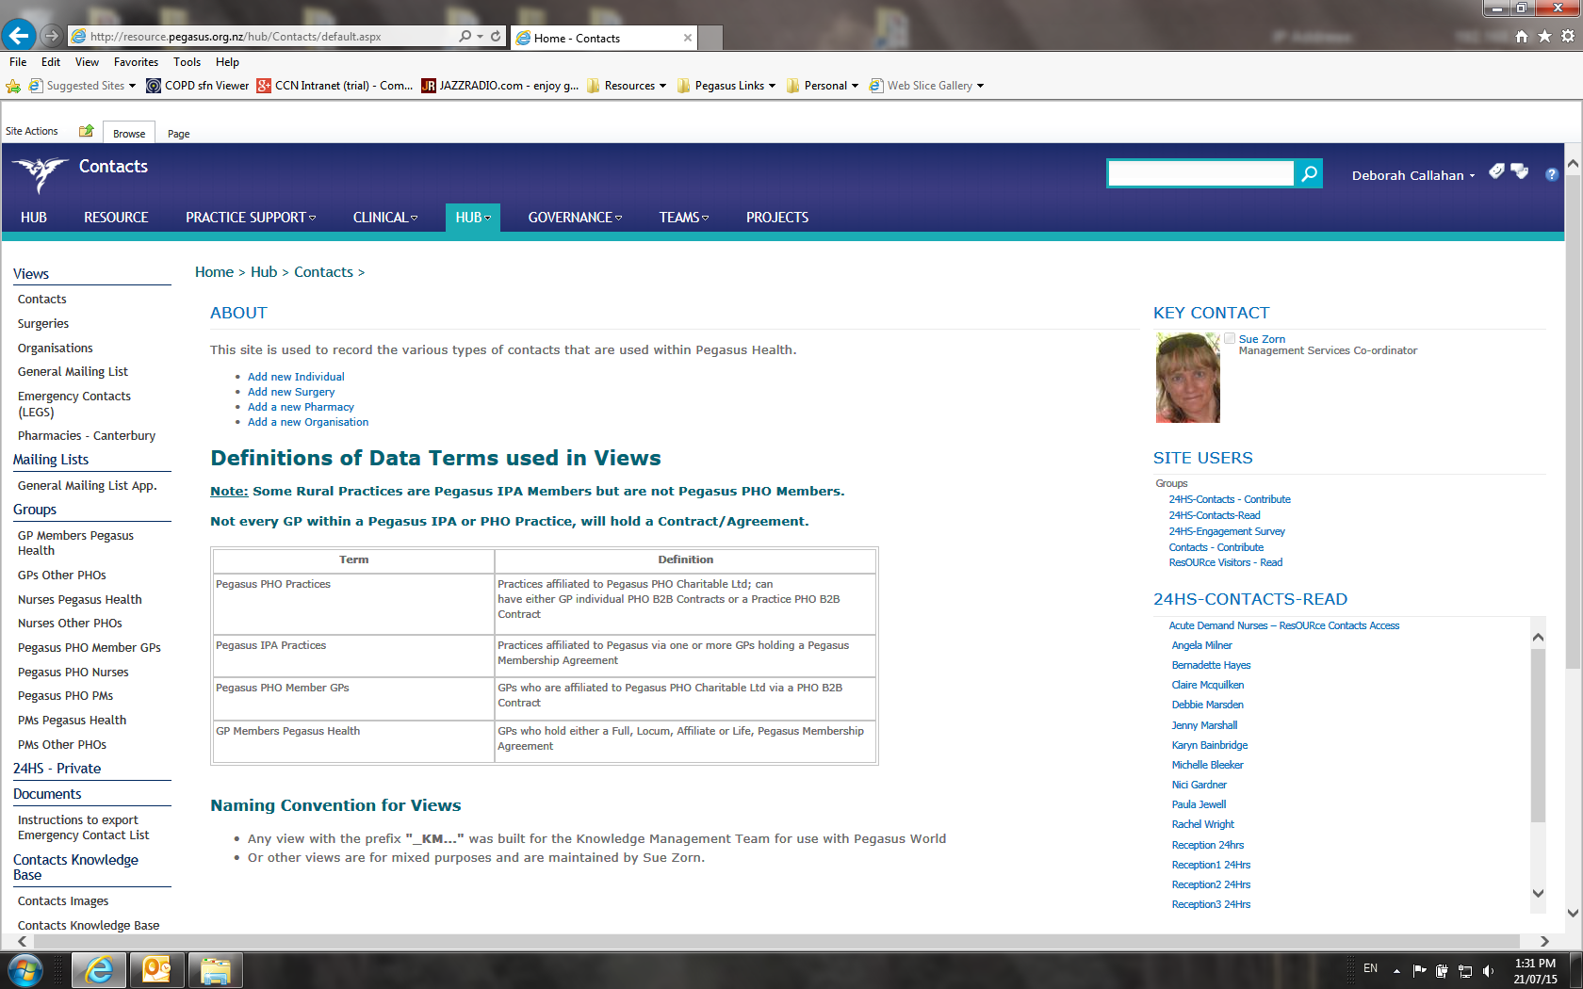
- Click on Emergency Contacts (LEGs) in the left column.
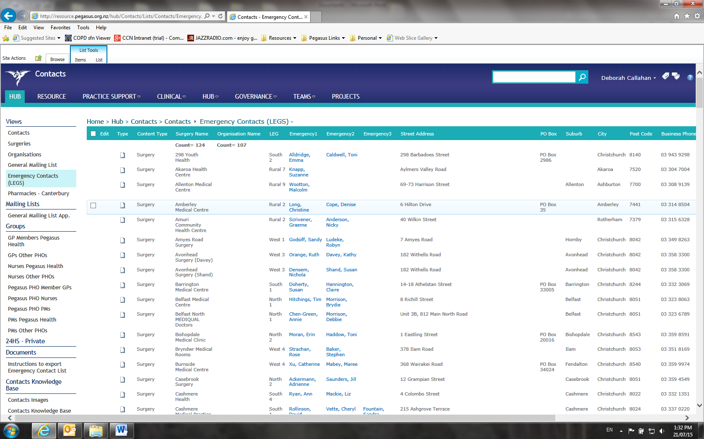
- Sort by LEG/Sector to find the sector you’re responsible for.
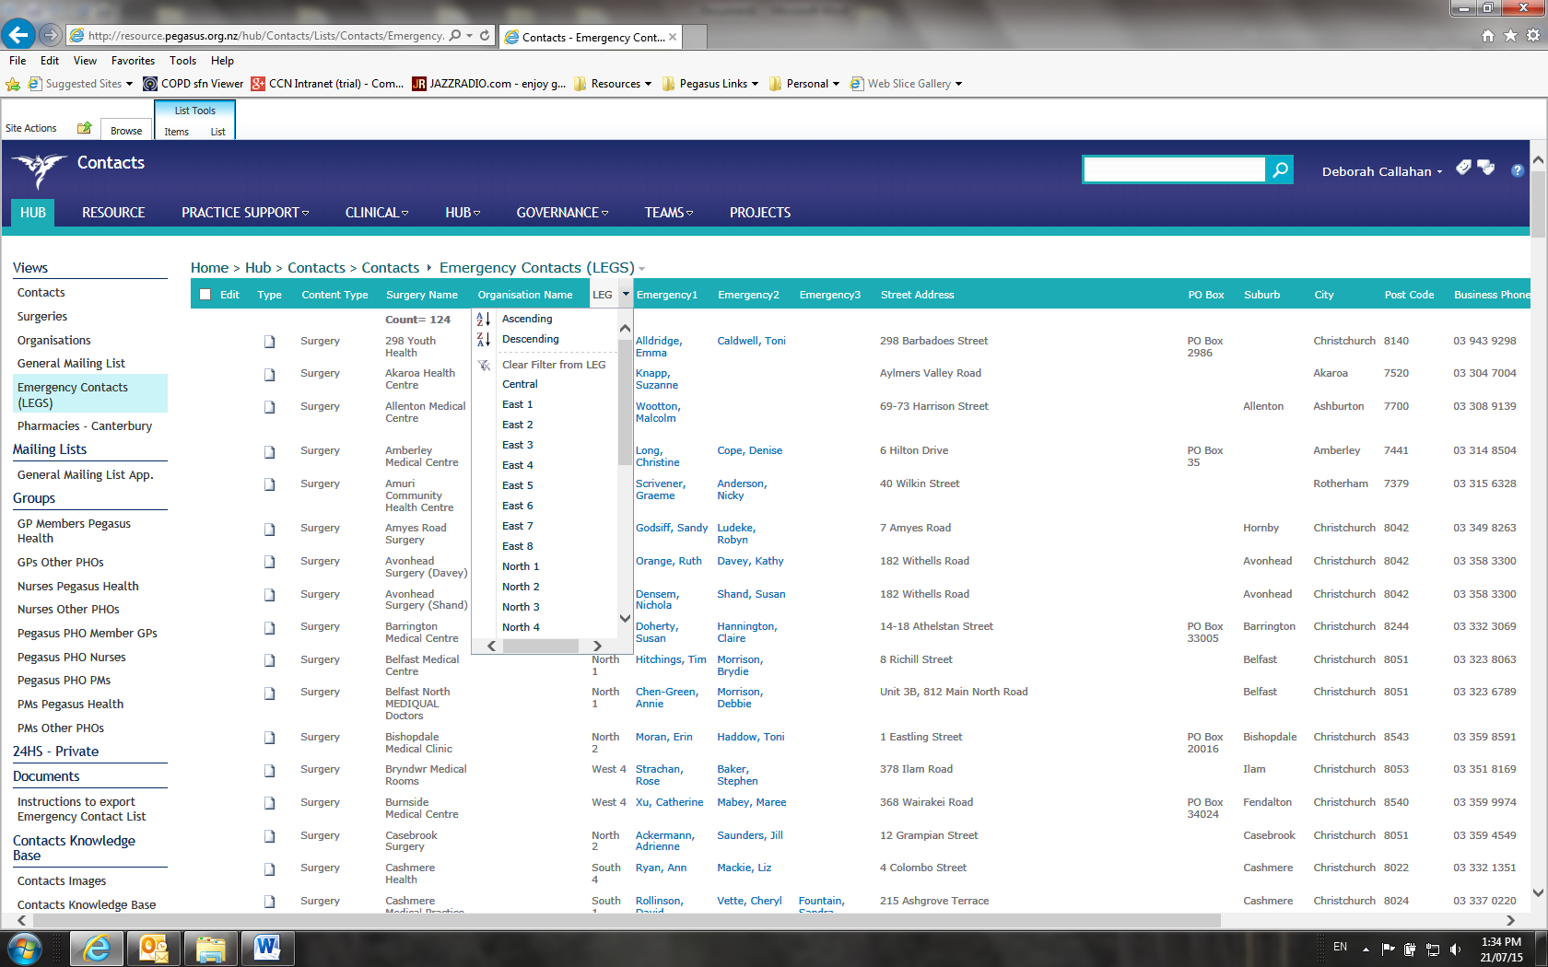
For example, Central sector:
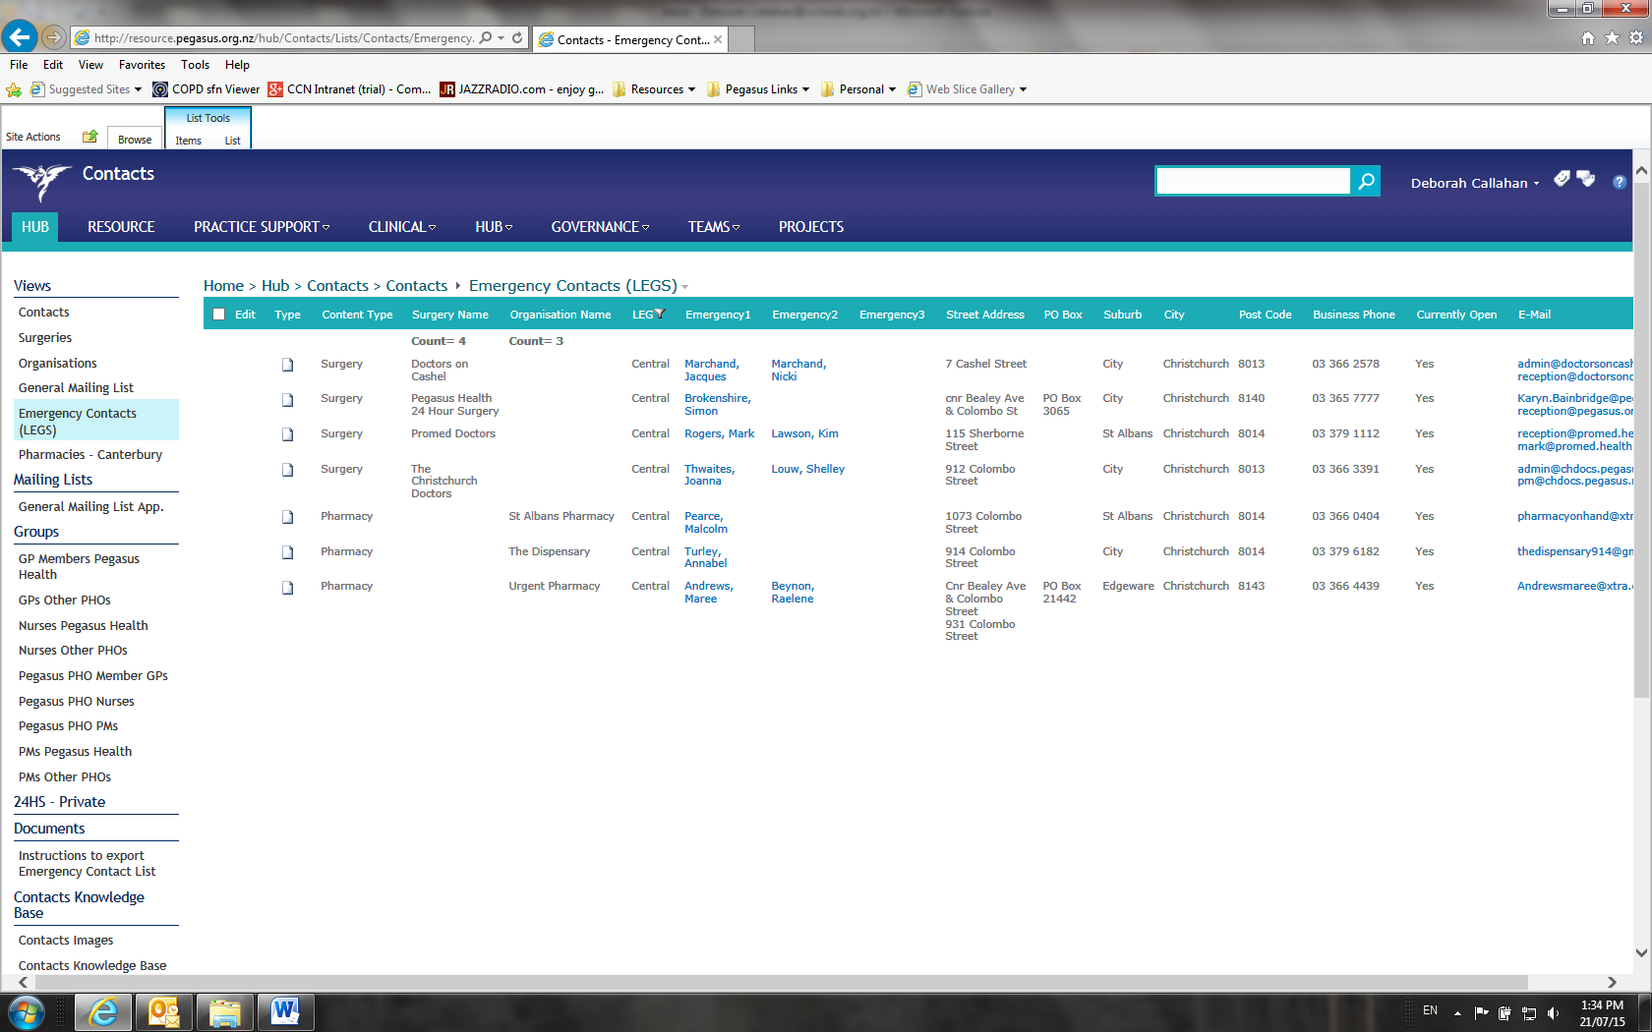
To view in Excel and print, click on Site Actions / List.
Then click on Export to Excel.
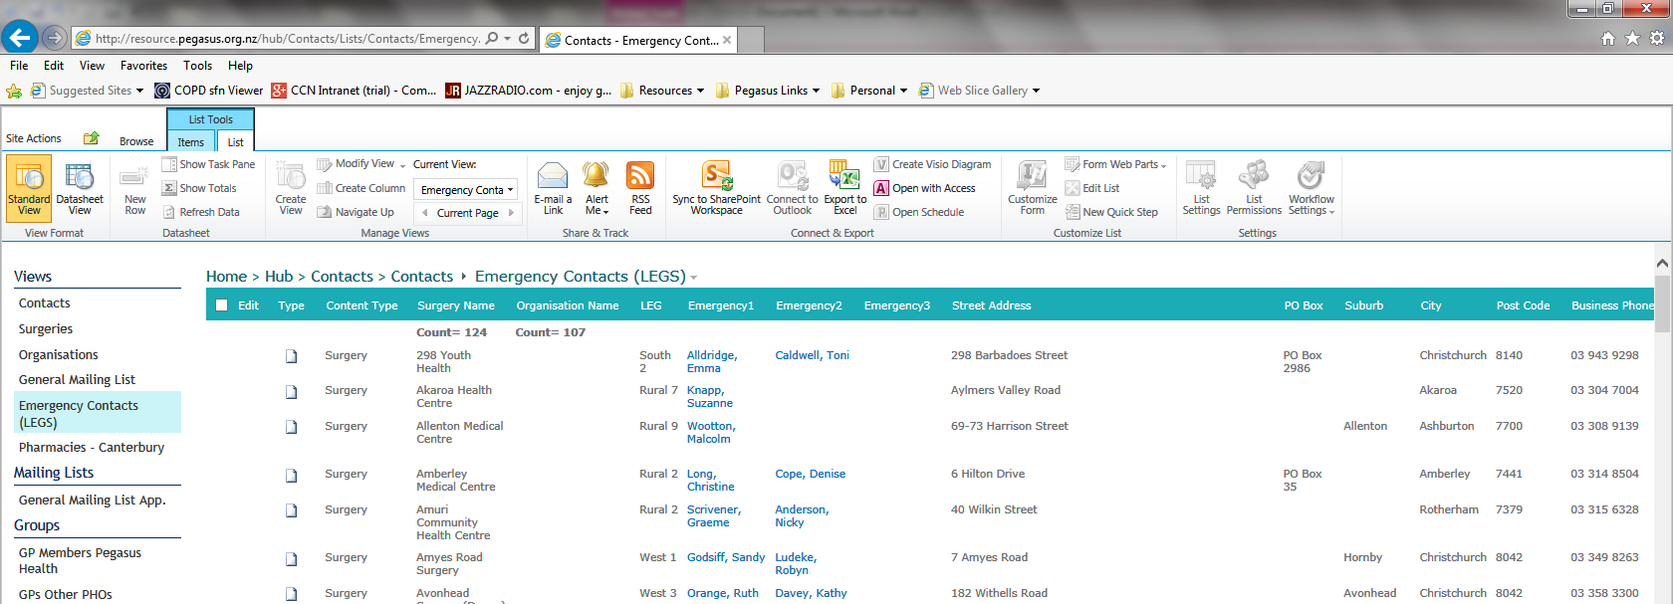
Click on Open.
And Enable.
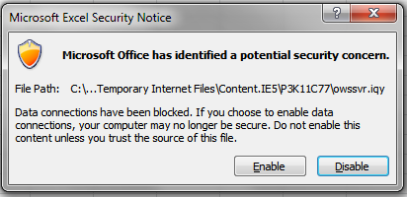
This will now open up the whole contact list in Excel, where you can filter the data by sector and print (check your page layout before printing – see next page).
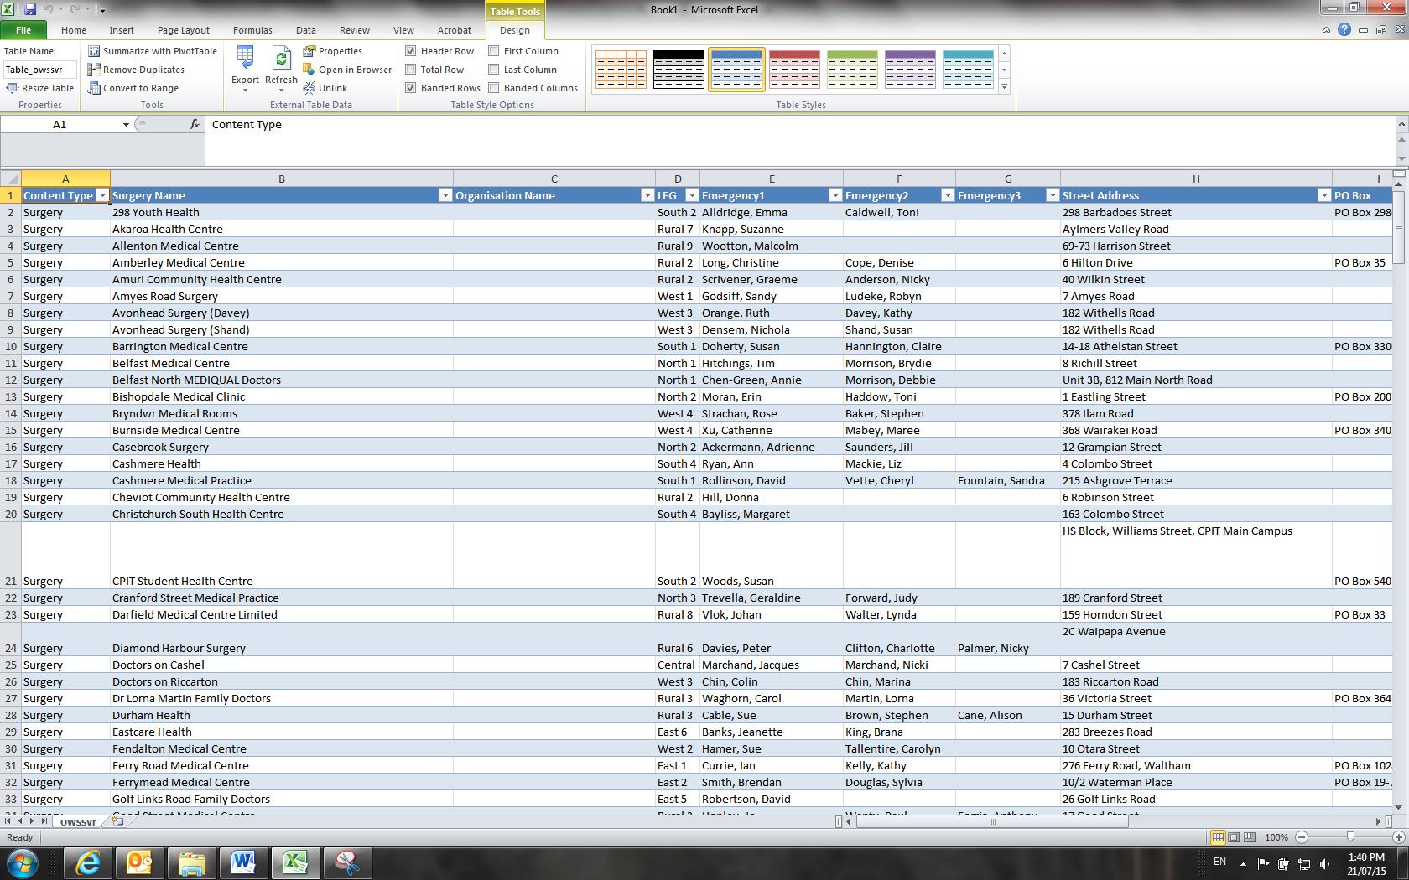
Go to Page Layout to make the document print on one page, for instance:

