**Funding for General Practice Consultations**

**14 March – 10 April 2011**

# Introduction

The 9 March Practice Viability notice advised that further information would be sent regarding subsidy for consultations for the rest of the month. This notice contains this new information.

Following the 22 February earthquake the DHB have funded a special package to enable appropriate access to healthcare. From Monday 14 March until 10 April 2011, the DHB have agreed to support targeted groups to ensure they continue to access treatment in the community.

The proposed subsidy covers two main areas: practice visits; and broadening the criteria for accessing funding for ADMS (Acute Demand). We have tried to make this notice clear and understandable. However, the complexity of these changes is acknowledged and it may take a couple of readings to comprehend.

# Practice Visits

GPs are to use their discretion within guidelines, at 2.1 below, when offering free healthcare to patients, including their enrolled patients and those who have been displaced because of the earthquake.

## Socioeconomically Deprived Patients

Poverty and health are closely linked. Those people with poverty issues require support to ensure they are able to visit their general practice teams. There are two groups in the post-earthquake recovery which will be supported by free healthcare:

* Those socioeconomically deprived prior to the earthquake
* Those socioeconomically deprived as a result of the earthquake

### Those socioeconomically deprived prior to the Earthquake, including those who receive:

* Domestic purposes benefit
* Independent youth benefit
* Sickness benefit
* Invalids benefit
* Unemployment benefit

### Those socioeconomically deprived after the Earthquake, who now receive

* One of the benefits as listed above
* Earthquake employment support package provided by WINZ/MSD
* Earthquake related bereavement grant from Red Cross
* Emergency and hardship grant from Red Cross
* Special food grants or food banks

**Aligned with a ‘high trust, low bureaucracy’ approach, the free visit allocation is to be the GP’s discretion, within the above guidelines**.

## Subsidised Practice Visits

The earthquake funding package will fund all eligible Casual patients at the enrolled patient level. That is, all Casual patients, eligible for public funded healthcare, will be charged the same patient fee as enrolled and funded patients. This applies to both GMS and ACC consults.

GMS should continue to be claimed for eligible patients. However, there will be no claw-back from the Casual patient’s practice.

The following diagram summarises the payment options; a detailed PMS guide is attached at Appendix 1.

GMS or First Level Service consult:



If a displaced person or casual sees you and is unable to pay (GP’s discretion, see criteria 2.1, above) you will claim from the DHB your normal co-payment plus a top-up subsidy. With the above fee example and an adult card-holder, this would be: GMS ($15.33) + top-up ($14.76) + Fee $35 = $65.

If the displaced person is able to pay you will claim the co-payment directly from the patient ($35) plus receive the GMS and top-up subsidies of $30; therefore totaling $65.

ACC consult: The ACC subsidy is claimed in the normal manner. Applying GP discretion (see criteria 2.1, above), if the patient cannot afford to pay the normal ACC co-payment, the DHB will pay this amount. See Appendix 1 for PMS claim instruction.

Radiology part charges, which have been funded to date, will continue for those in need, applying GP discretion, as above.

# Acute demand service (ADMS)

There are two new initiatives under Acute Demand (**Please read example scenarios, Appendix 2**):

1. The DHB would like GPs to widen the use of the ADMS to focus not only on those where you are preventing an admission to hospital, but to include those at risk of deteriorating to a point where they may require admission to Christchurch Hospital or ED if they do not attend primary care e.g. 78 year old with heart failure and COPD attends with swollen ankles and mild breathlessness. She has not been severely affected by the quake. ADMS can now cover the initial attendance at GP discretion, and follow up, including phone calls to check progress. *Logic: There is an acute illness, and she is at risk of hospital attendance.*
2. Practices can proactively manage their population who are at increased risk of hospital attendance or acute illness, and can charge this to ADMS. For example, contacting frail elderly or those with multiple chronic conditions once weekly. Practices can now claim up to five hours per week per 1,000 enrolled patients at 1.5 times their usual rates of pay for administrative, pharmacy, allied health or nursing staff. This funding is not to cover doctors.

ADMS utilisation across the practices will be reviewed for future planning.

# Payments

Please record all earthquake funded visits in your PMS in the manner described at Appendix 1.

Payments will be managed by Pegasus Health. Work is underway on an electronic PMS extract to submit all quake related claims. We will soon be able to advise when, where, and who to submit this extract.

If there are queries regarding this notice please use the following contacts:

* PMS queries, Pegasus Health helpdesk on 353 9990
* Quake funding subsidy and ADMS queries, Allan Masters (353 9981), Sue Zorn (353 9916), or Anne Dixon (353 9917)

Regards

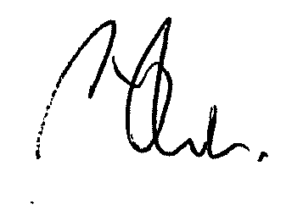

**Dr Phil Schroeder**

Primary Care Coordinator

Canterbury Primary Response Group

Appendices:

1. PMS Earthquake funded consultations as from 14 March 2011
2. AMDS Scenarios

**APPENDIX 1**

**PMS Earthquake funded consultations as from 14 March 2011**

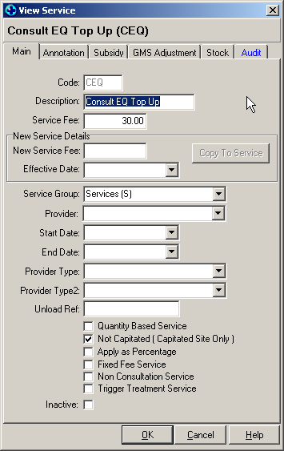

Non-Medtech users, please consult your vendors, who have received a copy of this instruction.

In Medtech32, go to **Setup / Accounting / Services**.

Click on the **Add New Service** icon, and enter a new service code called:

Code: **CEQ**,

Description: **Consult EQ Top Up**.

Service Fee: **30.00**.

**Tick** the box beside ‘Not Capitated’.

Click on the GMS Adjustment tab, and **enter all the amounts in the fields** as per the picture below.

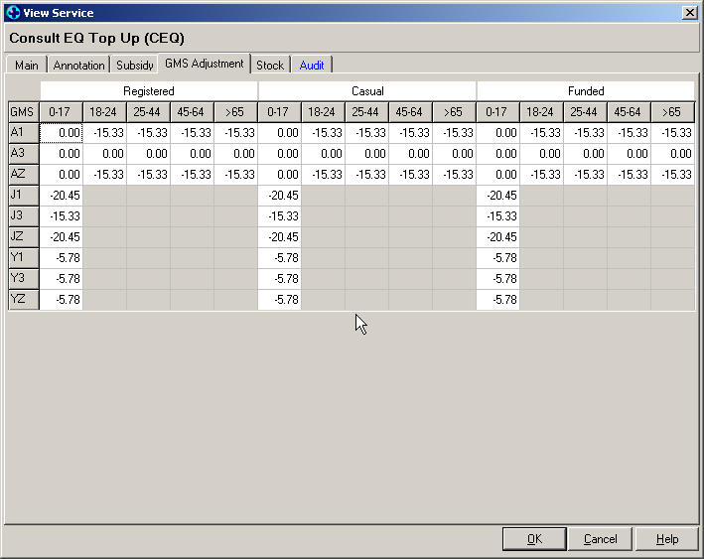

The above code is only to be used as per the instructions on page two.

If free ACC part charges (fees) are offered, continue to follow our previous instructions ‘Process for recording free GP visits on your PMS’.

**Instructions to follow for GMS consultations only**

1. **Is the patient eligible for an earthquake consultation?**

**NO**

**NO**

Create a new Invoice.

Change the Account holder to **QUAKE**

Enter the **C** for consultation.

Click on **OK** to save.

Create a new Invoice.

Do not touch the account holder. Leave it as is.

Enter the **C** for consultation. **Remember to change the fee to the amount you would charge a capitated pt for the same service and GMS code.**

Click on **OK** to save.

Create another new invoice.

Change the Account holder to **QUAKE**

Enter the **CEQ** service code.

Click on **OK** to save.

Is the patient a casual?

**YES**

Is the patient a Casual?

**YES**

**NO**

**YES**

Create a new Invoice.

Do not touch the account holder. Leave it as is.

Enter the **C** for consultation.

Click on **OK** to save.

Create a new Invoice.

Change the Account holder to **QUAKE**

Enter the **C** for consultation. **Remember to change the fee to the amount you would charge a capitated pt for the same service and GMS code.**

Enter the **CEQ** service code.

Click on **OK** to save.

**APPENDIX 2**

**ADMS Scenarios**

Five year old with recurrent asthma who presents with an exacerbation. ADMS can cover the initial attendance and follow up, including phone calls to check progress.

*Logic: Parents need to know that they can attend the doctor with conditions that risk attendance at ED or hospital admission.*

Eighteen year old with Type 1 diabetes who has lost his meter in the quake presents with a urinary tract infection. ADMS can cover the initial attendance, provision of new meter and education around it, treatment of the infection and follow up.

*Logic: This person is at high risk of requiring hospital attendance, and cost is a significant barrier to presenting in primary care.*

Twenty-five year old accountant attends with flu-like symptoms to their enrolled practice. They have not been affected by the earthquake. They will pay the normal fees.

*Logic: This person is not at high risk of hospital attendance and does not have high health needs.*

Seventy-eight year old with heart failure and COPD attends for regular medication and review. She has not been severely affected by the quake. This person has a Disability Allowance and Care Plus funding. She will pay the normal fees.

*Logic: There is no acute illness, and she is not at increased risk of hospital attendance.*

Seventy-eight year old with heart failure and COPD attends with swollen ankles and mild breathlessness. She has not been severely affected by the quake. ADMS can cover the initial attendance and follow up, including phone calls to check progress.

*Logic: There is an acute illness, and she is at risk of hospital attendance.*

Seventy-eight year old with heart failure and COPD attends for regular medication and review. She has severely affected by the quake, in that her house has been severely damaged, and she is very anxious. ADMS can cover the initial attendance, pharmacy $3.00 fee and follow up, including phone calls to check progress.

*Logic: Although there is no acute illness, she is at increased risk of hospital attendance if not appropriately managed in primary care.*

Sixty-four year old with lung cancer presents to a rural practice as a casual patient with severe pain requiring three consultations for analgesia and palliative care. ADMS will cover these consultations.

*Logic: Although not covered by usual PHO palliative care provisions, ADMS will cover these consultations as he is at risk of acute medical admission for pain management.*