CANTERBURY PRIMARY RESPONSE GROUP UPDATE

## Tuesday 28th June 2016

**Important information for all GP teams, Community Pharmacists, District Nurses and Aged Care Facilities – Please share this with everyone in your team**

* Whilst influenza is not yet widely circulating, we encourage you to continue to promote flu vaccinations within your area especially recalling your patients 65 years and over, pregnant women and those with chronic conditions including children.

Canterbury Influenza-like illness rates (May—Sep) 2013—2016

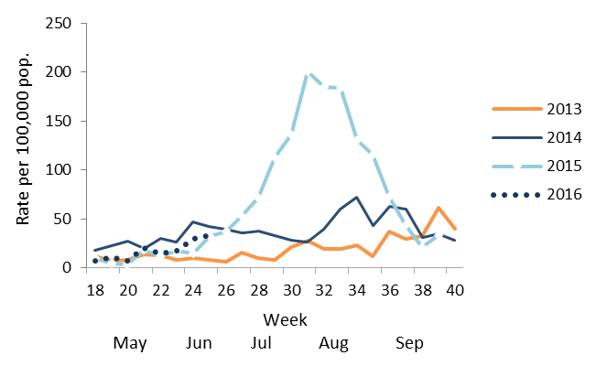

* 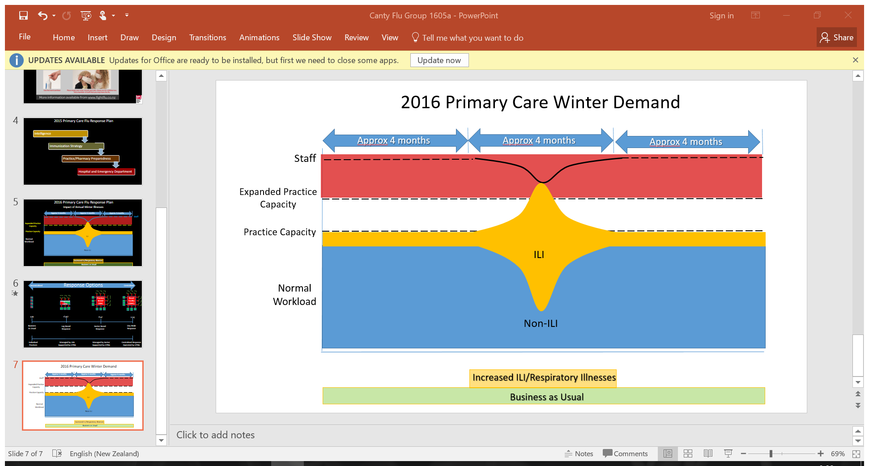The northern hemisphere saw an influenza season dominated by H1N1 (Swine Flu). However, Canterbury swabs have shown a preponderance for H3N2 to date. While vaccinating we bear in mind that hospitalisation rates for H3N2 are highest in the very young and the elderly.
* Please remember that one of your best protections in your facilities is to ensure your staff are vaccinated as well. Many businesses choose to fund this if not free to staff otherwise.
* In a typical year the ‘flu’ season causes a wave of illness in the community lasting 8-12 weeks, with a corresponding wave in healthcare demand and healthcare worker absenteeism.
* Respiratory virus reports are produced and posted on HealthPathways weekly by Community and Public Health and CPRG with input on any salient points addressed in the key messages. On occasions where activity is mounting this will be emailed out. Please see the attachment with this current communication.
* The peak of a very high activity year (250/100,000 ILI rates) would see the average full time GP seeing **4 new cases of influenza-like illness weekly**. These patients often present with relatively sudden onset myalgia, cough and headaches along with high fevers. To best provide for your patients during this period planning might include:
* Ensuring good signage, masks, alcohol hand-wash availability for all presenting with coughs and colds.
* Changing booking systems to allow for same day triaged appointments and/or extended hours.
* Consideration limiting holidays of doctors and staff over the busiest months (typically August/September).
* Consider using acute demand services to either deal to acute cases and/or repeat visits required.

Kind regards,

Dr Phil Schroeder, Canterbury Primary Response Group