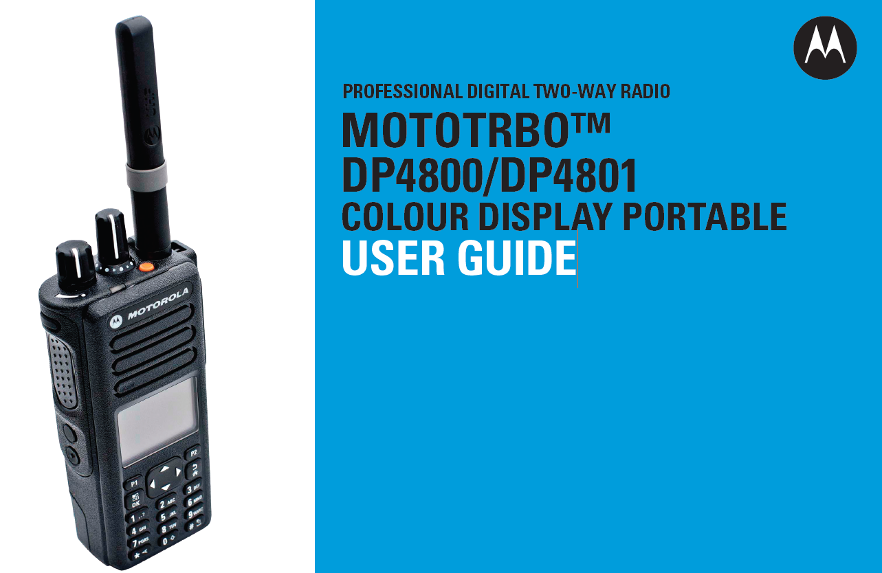

A simple how to guide for the Emergency RT’s
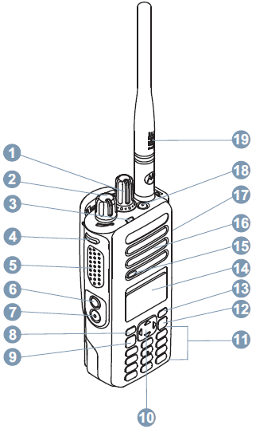 | 1 Channel Selector Knob  2 On/Off/Volume Control Knob  3 LED Indicator  4 Side Button 1  5 Push-to-Talk (PTT) Button  6 Side Button 2  7 Side Button 3  8 Front Button P1  9 Menu/OK Button  10 4-Way Navigation Button  11 Keypad  12 Back/Home Button  13 Front Button P2  14 Display  15 Microphone  16 Speaker  17 Universal Connector for Accessories  18 Emergency Button  19 Antenna

Diagram 1 – Radio Controls
Weekly radio checks
Radio checks on the Emergency RT network are carried out every Friday at 09.30.
Make sure the volume is turned up sufficiently on your RT to hear when you are called up
- Remove the RT from the charger using one hand to hold and support the charger and the other hand to remove the RT (NOTE – Do NOT lift the RT by the aerial at any time.)
- When you hear your call sign being called
  - Lift the RT to a position approximately 20cm in front of your face
  - Press the “Push-to-Talk” (PTT) button (⑤ on Diagram 1). Keep it pressed down.
  - Wait for approximately two seconds then respond (otherwise the first part of speech is lost).
  - When you have finished speaking release the PTT button.
- Replace the RT back into the charger by aligning the groove on each side of the battery with the corresponding raised rails on each side of the charger pocket. Press the battery towards the rear of the pocket as you gently slide the battery into the charger. This should ensure a complete contact between the charger and the battery. Once the battery is properly seated into the pocket, the charger indicator illuminates. Refer to Table 2 for colour indications.

Example of RT procedure
“All positions, stand by for the weekly radio checks for Friday the 16th of September. CDHB ECC to Christchurch Hospital EOC, Radio Check, over.”
“This is Christchurch Hospital EOC, loud and clear, over.”
“Thank you Christchurch Hospital EOC, you are loud and clear also. ECC to TPMH Reception, Radio Check, over”.
“This is TPMH Reception, you are loud and clear, over.”

The usual order of contact is CDHB ECC to Christchurch Hospital EOC, then TPMH Reception, Oxford Terrace Corporate, Burwood, A&M Moorhouse, 24HR Bealey, A&M Riccarton, CDHB Supply, Hillmorton, Nurse Maude, NZ Blood Services Addington, St Georges, CPRG, Forte Health, Southern Cross, Canterbury Radiology and Canterbury Civil Defence.
If nothing is heard from a station after two attempts we will move on to the next on the list and return to them at the end. If everyone is listening at 09.30 on a Friday the complete radio checks should take just over 4 minutes.
Changing the battery
On the first Friday of the month, on completion of the weekly radio checks, change over the battery for the spare, by first switching off the RT then following these instructions.
- Turn off the RT by rotating the On/Off/Volume Control knob (② in Diagram 1) fully counter-clockwise until you hear a click. A brief “Powering Down” message may appear on the RT display.
- Remove the RT from the charger using one hand to hold and support the charger and the other hand to remove the RT (NOTE – Do NOT lift the RT by the aerial at any time.)
- Remove the Belt Clip by pressing the belt clip tab away from the battery using a key, then slide the clip upward and away from the radio.
- Remove the Battery by moving the battery latch (Ⓐ in Diagram 2) into the unlock position and hold, and slide the battery down and off the rails.
- Replace with the spare battery. Align the battery with the rails on the back of the RT unit. Press the battery firmly, and slide upwards until the latch snaps into place. Slide battery latch into lock position.
- Replace Belt Clip by aligning the grooves on the clip with those on the battery and press downward until you hear a click.
- Place the RT back into the charger by aligning the groove on each side of the battery with the corresponding raised rails on each side of the charger pocket. Press the battery towards the rear of the pocket as you gently slide the battery into the charger. This should ensure a complete contact between the charger and the battery. Once the battery is properly seated into the pocket, the charger indicator illuminates. Refer to Table 1 for colour indications.
- Turn on the RT by rotating the On/Off/Volume Control knob clockwise until you hear a click. The message “MOTORBO ™” on the RT display will momentarily display followed by a message “CITY”. Turn the volume up to the original level.
- Check the LED indicator ③ If blinking red leave to charge up and recheck for blinking green later.
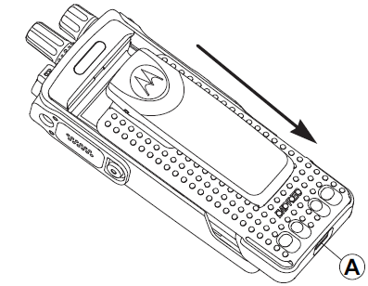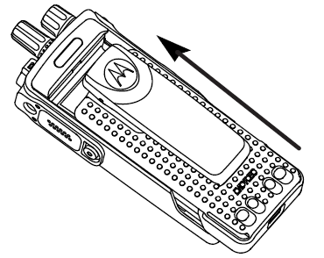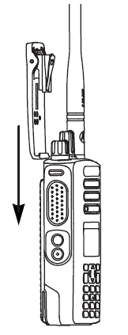
Diagram 2 Removing the battery Diagram 3 Replacing the battery Diagram 4 Attaching belt clip
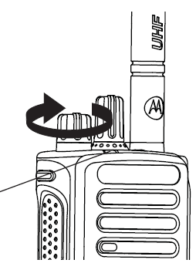
③
Diagram 5 On/Off/Volume Control Knob.
LED ③ indicator | Meaning
Blinking red | Radio is transmitting at low battery condition, receiving an emergency transmission, has failed the self-test upon powering up, or has moved out of range if radio is configured with Auto-Range Transponder System
Solid yellow | Radio is monitoring a conventional channel or in Bluetooth Discoverable Mode.
Blinking yellow | Radio is scanning for activity or receiving a Call Alert, flexible receive list is enabled or all local Linked Capacity Plus channels are busy.
Double blinking yellow | Radio is no longer connected to the repeater while in Capacity Plus or Linked Capacity Plus; all Capacity Plus or Linked Capacity Plus channels are currently busy. Auto Roaming is enabled, radio is actively searching for a new site. Also indicates that radio has yet to respond to a group call alert, or radio is locked.
Solid green | Radio is powering up (5-10 seconds then changes) or transmitting (stays on all while Push To Talk (PTT) button [⑤ in Diagram 1] is depressed).
Blinking green | (Normal state) Radio is monitoring channel, receiving a non-privacy-enabled call or data, detecting activity, or retrieving Over-the-Air Programming transmissions.
Double blinking green | Radio is receiving a privacy-enabled call or data
Table 1 LED indicator on RT colour meanings

Charge Indicator | Description
Single Blink Green | Charger has successfully powered up.
Steady Red | Battery is in rapid charge mode.
Blinking Green | Battery has completed rapid charge (> 90 % available capacity). Battery is in Top-Off charge (Trickle charge).
Steady Green | Battery has completed charging and is fully charged.
Blinking Orange | Battery is recognized by charger but is waiting to charge. (Either the battery voltage is too low or the battery temperature is too low or too high to allow charging. When this condition is corrected, the battery will automatically begin charging.)
Blinking Red | Battery is unchargeable or not making proper contact.
Steady Orange | (This feature applies to IMPRES batteries only)  Battery is in recondition or initialization mode. The length of time the charger remains in this mode depends upon the state of charge remaining in the battery when inserted. (Fully charged batteries require more time to recondition – 8 to 12 hours or more – than fully discharged batteries.)
Blinking Red / Green | (This feature applies to IMPRES batteries only)  Battery has completed charging and is fully charged. Battery continues to be usable, but may be nearing the end of its rated service life.
Table 2 IMPRES Battery Charging Indicators
Radio Check levels
With this being a digital network the signals will have a fairly consistent quality as the receiver moves away from the transmitter until reaching a threshold distance. At this threshold point the signal quality takes a severe drop and is lost. Thus the signal should always be “Loud and Clear” or ‘Nothing Heard’ (response from transmitting station if no answer received). There may be a case where station ‘B’ in between two stations ‘A’ and ‘C’ can hear both but A cannot hear C. In this case Station B can offer to ‘relay’ the message from Station A to C.
Aids to accuracy – Prowords
Standard, easily pronounced words used to indicate specific meanings to help speed up message handling on a radio network, reducing the chance of an error being introduced into a message.
Proword | Meaning
Over | I have finished transmitting – go ahead with your reply
Out | This conversation is ended – I do not expect a reply – the channel is now free
Go Ahead | I am ready to copy your message
Figures | Numerals follow
I Spell | The next word will be spelled with phonetics
Roger | Message received and understood
Say again | Re-transmit all (or all after) your transmission
I say again | I will re-transmit the message or part message
No Duff | May be used during an exercise to indicate that this is not an exercise message but real.
EMERGENCY  EMERGENCY | Only to be used when there is ‘grave or imminent danger to life’.  Immediate assistance is required.
Sitrep | Means give a situation report at your location
Listening, out | Channel is now free, I will be monitoring for any other transmissions
Wait, over | I do not have the answer or information to hand I will attempt to source the answer or information requested shortly but until then I have finished talking and do not expect a reply. Can be suffixed with a number to indicate estimated number of minutes until a reply can be expected. ex: WAIT TWO indicates "you should expect my reply in approximately two minutes.
Radio Check | Request a report on reception of the transmission at your location
So from that you can see the mistake they always make in the movies when they say “Over and out” (I have finished and waiting for your reply but I am not expecting you to reply!)

Phonetic Alphabet
Letter | Phonetic | Pronounced |  | Letter | Phonetic | Pronounced
A | ALPHA | AL fah |  | N | NOVEMBER | no VEM ber
B | BRAVO | BRAH voh |  | O | OSCAR | OSS cah
C | CHARLIE | CHAR lee |  | P | PAPA | pah PAH
D | DELTA | DELL ta |  | Q | QUEBEC | kay BECK
E | ECHO | ECK oh |  | R | ROMEO | ROW me oh
F | FOXTROT | FOKS trot |  | S | SIERRA | see AIR rah
G | GOLF | GOLF |  | T | TANGO | TANG go
H | HOTEL | hoh TELL |  | U | UNIFORM | YOU nee form
I | INDIA | IN dee ah |  | V | VICTOR | VIK tah
J | JULIET | JEW lee ett |  | W | WHISKEY | WISS key
K | KILO | KEY loh |  | X | X-RAY | ECKS ray
L | LIMA | LEE mah |  | Y | YANKEE | YANG key
M | MIKE | MIKE |  | Z | ZULU | ZOO loo
0 | ZERO | ZEE row |  | 10 | ONE ZERO | WUN ZEE row
1 | ONE | WUN |  | 11 | ONE ONE | WUN WUN
2 | TWO | TOO |  | 15 | ONE FIVE | WUN FIFE
3 | THREE | TREE |  | 20 | TWO ZERO | TOO ZEE row
4 | FOUR | fo WER |  | 100 | ONE HUNDRED | WUN HUNDRED
5 | FIVE | FIFE |  | 357 | THREE FIVE SEVEN | TREE FIFE SE ven
6 | SIX | SIX |  | 1000 | ONE THOUSAND | WUN TOU-zand
7 | SEVEN | SE ven |  | 34,000 | THREE FOUR THOUSAND | TREE fo WER TOU-zand
8 | EIGHT | AIT |  | 62,021 | SIX TWO ZERO TWO ONE | SIX TOO ZEErow TOO WUN
9 | NINE | NIN er |  | 1.5 | ONE DECIMAL FIVE | WUN DAY see mal FIFE

Guide to VOICE PROCEDURE
Voice procedure is a set of rules designed to provide SECURITY, ACCURACY and DISCIPLINE when speaking on the radio. If you neglect these rules then it will be SAD.

SECURITY
(a) Think before you speak.
(b) Use correct procedure
(c) Be brief

ACCURACY
The necessity for clear speech on two-way radio cannot be over emphasised. Therefore the RSVP system should be used to enhance better voice procedure and technique.
R RHYTHM Adequate pauses.
S SPEED Slower than usual conversation.
V VOLUME Speak directly into the microphone.
P PITCH The voice should be pitched at a higher level than for normal conversation.

DISCIPLINE
Radio discipline is the responsibility of every operator, and should adhere to the following:
(a) Listen before you speak.
(b) Use correct voice procedure.
(c) Answer all calls promptly.
(d) Keep the airways free of unnecessary talk.
(e) Be brief and to the point

If you have any questions or queries please contact David Collins on extension 86351 (DDI 03 378 6351),
or Mob 027-538-3865 or by email David.Collins@cdhb.health.nz

